# Defensive situations and strategies

* **Single to left: bases empty**
* **Single to center: bases empty**
* **Single to right: bases empty**
* **Single to left: runner on first, or runners on first and third**
* **Single to center: runner on first, or runners on first and third**
* **Single to right: runner on first or runners on first and third**
* **Single to left: runner on second, runners on first and second, or bases loaded**
* **Single to center: runner on second, runners on first and second, or bases loaded**
* **Single to right: runner on second, runners on first and second, or bases loaded**
* **Double, possible triple down the left field line: bases empty**
* **Double, possible triple to the left center field gap: bases empty**
* **Double, possible triple to the right center field gap: bases empty**
* **Double, possible triple down the right field line: bases empty**
* **Double, possible triple down the left field line: runners on base**
* **Double, possible triple to the left center field gap: runners on base**
* **Double, possible triple to the right center field gap: runners on base**
* **Double, possible triple down the right field line: runners on base**
* **Sacrifice bunt: runner on first**
* **Sacrifice bunt: runners on first and second, the infield goes for the out at first**
* **Wheel play: batter puts down a sacrifice bunt with runners on first and second, th****e** **defense goes for the force out at third**
* **Wheel play fake: runners on first and second with a pick-off play going to second**
* **Pop fly to shallow right field**
* **Pop fly to shallow left field**
* **Pop fly to shallow center field**

# Single to left: bases empty

* + 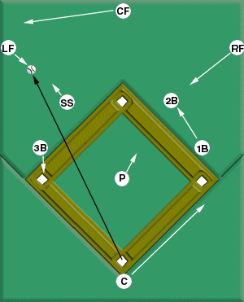**Catcher:** Cover first base in case the runner takes a too-wide turn
  + **Pitcher:** Back up any throw to second base
  + **First baseman:** Check that the batter touches first base and then back up the incoming throw to second base
  + **Second baseman:** Cover second base
  + **Shortstop:** Pursue the ball; then line up between the left fielder and second base to take the cut-off throw
  + **Third baseman:** Cover third base
  + **Left fielder:** Field the ball and throw it to the cut-off man (the shortstop). If the shortstop is out of position, throw to second base
  + **Center fielder:** Run to back up the left fielder
  + **Right fielder:** Move toward the infield to cover a poor throw from the left fielder to the second baseman.

# Single to center: bases empty

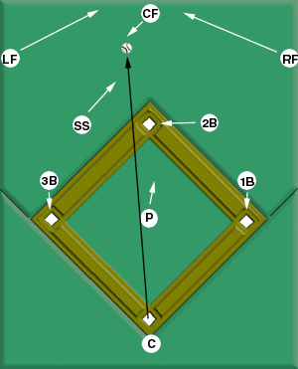

* + **Catcher:** Cover home plate.
  + **Pitcher:** Stay near the mound and back up any throw to second base.
  + **First baseman:** Make sure the batter touches first base, and then cover the base inside.
  + **Second baseman:** Go to second base to take the throw.
  + **Shortstop:** Go out to be the cut-off man for second base.
  + **Third baseman:** Cover third base.
  + **Left fielder:** Back up the center fielder.
  + **Center fielder:** Field the ball and throw it to second base.
  + **Right fielder:** Back up the center fielder.

# 

# Single to right: bases empty

* + 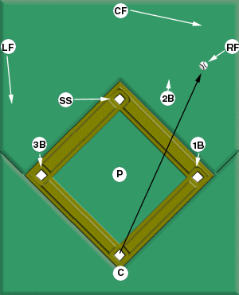**Catcher:** Cover home plate
  + **Pitcher:** Follow the flight of the ball and then decide where to back up (usually second base)
  + **First baseman:** Check that the batter touches first base and then cover the base inside
  + **Second baseman:** Pursue the ball; then take the cut-off position between the right fielder and second base
  + **Shortstop:** Cover second base
  + **Third baseman:** Cover third base
  + **Left fielder:** Move toward the infield in case the right fielder makes a bad throw to second base
  + **Center fielder:** Back up the right fielder
  + **Right fielder:** Field the hit and make the cut-off to the second baseman. If the second baseman is out of position, throw it to second base.

# Single to left: runner on first, or runners on first & third

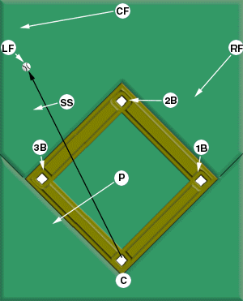

* + **Catcher:** Cover home plate
  + **Pitcher:** Follow the flight of the ball and then decide where to back up (usually third base)
  + **First baseman:** Check that the batter touches first base and then cover the base inside
  + **Second baseman:** Cover second base
  + **Shortstop:** Line up between the left fielder and third base for the cut-off throw
  + **Third baseman:** Back up the shortstop (but also cover third)
  + **Left fielder:** Field the ball and throw it to the cut-off man (the shortstop). If the shortstop is out of position, throw it to third base
  + **Center fielder:** Back up the left fielder
  + **Right fielder:** Move toward the infield to field any bad throws

# Single to center: runner on first, or runners on first & third

* + 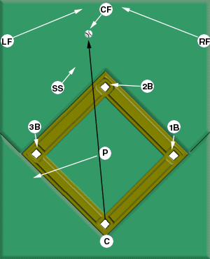**Catcher:** Cover home plate.
  + **Pitcher:** Back up the throw to third.
  + **First baseman:** Make sure the batter touches first base, and then cover the base inside.
  + **Second baseman:** Cover second.
  + **Shortstop:** Line up for the cut-off throw between the center fielder and third base.
  + **Third baseman:** Cover third base.
  + **Left fielder:** Back up the center fielder.
  + **Center fielder:** Field the hit and throw it to the cut-off man (the shortstop).
  + **Right fielder:** Back up the center fielder.

# Single to right: runner on first, or runners on first & third

* + 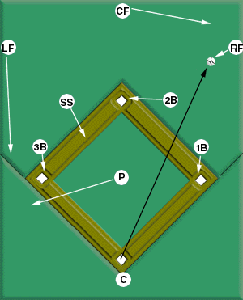**Catcher:** Cover home plate
  + **Pitcher:** Back up third base
  + **First baseman:** Make sure the batter touches first. base, and then cover the base inside
  + **Second baseman:** Cover second
  + **Shortstop:** Line up for the cut-off throw between the right fielder and third base
  + **Third baseman:** Cover third base
  + **Left fielder:** Back up the throw to third base
  + **Center fielder:** Back up the right fielder
  + **Right fielder:** Field the hit and throw it to the cut-off man (the shortstop)

# Single to left: runner on second, or runners on

**first and second, or bases loaded**

* + 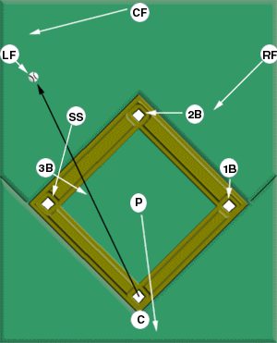**Catcher:** Cover home plate
  + **Pitcher:** Back up the throw at home plate
  + **First baseman:** Make sure the batter touches first base, and then cover the base inside
  + **Second baseman:** Cover second base
  + **Shortstop:** Cover third base
  + **Third baseman:** Take the cut-off position for a throw to home plate
  + **Left fielder:** Field the hit and throw it to the cut-off man (the third baseman)
  + **Center fielder:** Back up the left fielder
  + **Right fielder:** Back up any throw to second

# 

# Single to center: runner on second, or runners on

**first and second, or bases loaded**

* + 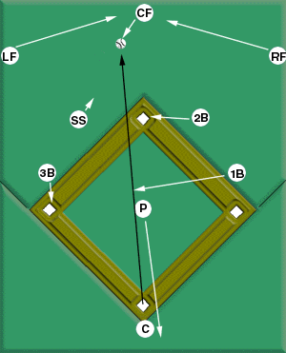**Catcher:** Cover home plate.
  + **Pitcher:** Back up the catcher at home plate.
  + **First baseman:** Take the cut-off position near the mound for a throw to home plate.
  + **Second baseman:** Cover second base.
  + **Shortstop:** Take the cut-off position for a throw to third base.
  + **Third baseman:** Cover third base.
  + **Left fielder:** Back up the center fielder and then become a quarterback. Tell the center fielder where the throw is going.
  + **Center fielder:** Field the hit, listen for the left or right fielder's instructions, throw to one of the cut-off men: the shortstop (if the play is at third base) or the first baseman (if the play is at the plate).
  + **Right fielder:** Back up the center fielder and then become a quarterback. Tell the center fielder where the throw is going.



# Single to right: runner on second, or runners on

**first and second, or bases loaded**

* + 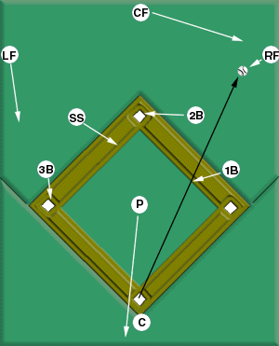**Catcher:** Cover home plate
  + **Pitcher:** Stand outside the base paths between third base and home plate, watch the play evolve, and back up the throw (usually at home plate)
  + **First baseman:** Take the cut-off position for the throw to home plate
  + **Second baseman:** Cover second base
  + **Shortstop:** Take the cut-off position for the throw to third base
  + **Third baseman:** Cover third base
  + **Left fielder:** Come toward third base in order to be able to help out third or second base
  + **Center fielder:** Back up the right fielder and tell him where to throw
  + **Right fielder:** Field the ball, listen for the center fielder's instructions, throw to the appropriate cut-off man: the shortstop (on a play at third base) or the first baseman (on a play at home plate)

# Double, possible triple down the left field line: bases empty

* + 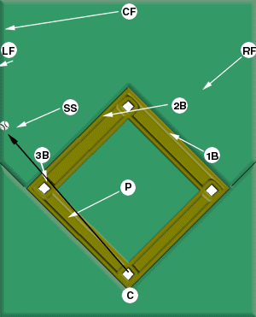**Catcher:** Cover home plate
  + **Pitcher:** Back up third base
  + **First baseman:** Make sure the batter touches first base; then trail the runner to second base
  + **Second baseman:** Go to the trail position behind the shortstop.
  + **Shortstop:** Take the cut-off position down the left field line
  + **Third baseman:** Cover third base
  + **Left fielder:** Field the hit and make the cut-off throw to the shortstop
  + **Center fielder:** Back up the left fielder
  + **Right fielder:** Back up any throw to second base

# Double, possible triple to the left center field gap:

**bases empty**

* + 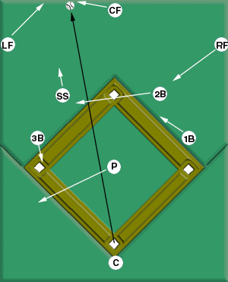**Catcher:** Cover home plate
  + **Pitcher:** Back up third base
  + **First baseman:** Make sure the batter touches first base; then trail him to second
  + **Second baseman:** Go to the trail position behind the shortstop - 20-30 feet behind based on age and field size
  + **Shortstop:** Line up with third base and the fielder for the cut-off throw
  + **Third baseman:** Cover third base
  + **Left fielder:** Back up the center fielder
  + **Center fielder:** Field the hit and make the cut-off throw to the shortstop
  + **Right fielder:** Back up any throw to second base

# Double, possible triple to the right center field gap:

**bases empty**

* + 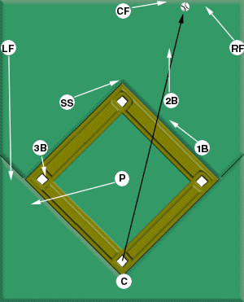**Catcher:** Cover home plate.
  + **Pitcher:** Back up third base.
  + **First baseman:** Make sure the batter touches first base; then trail him to second.
  + **Second baseman:** Line up with third base and the center fielder for the cut- off throw.
  + **Shortstop:** Go to the trail position behind the second baseman- 20-30 feet behind based on age and field size
  + **Third baseman:** Cover third base.
  + **Left fielder:** Back up any throw to third base.
  + **Center fielder:** Field the hit and make the cut-off throw to the second baseman.
  + **Right fielder:** Back up the center fielder.

# Double, possible triple down the right field line: bases empty

* + 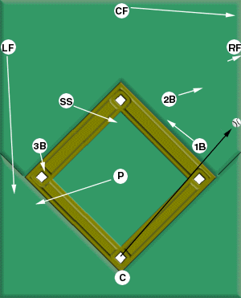**Catcher:** Cover home plate.
  + **Pitcher:** Back up third base.
  + **First baseman:** Make sure the batter touches first base; then trail him to second.
  + **Second baseman:** Line up with third base and the fielder for the cut-off throw.
  + **Shortstop:** Go to the trail position behind the second baseman -20-30 feet behind based on age and field size
  + **Third baseman:** Cover third base.
  + **Left fielder:** Back up any throw to third base.
  + **Center fielder:** Back up the right fielder.
  + **Right fielder:** Field the hit and make the cut-off throw to the second baseman.

# Double, possible triple down the left field line: runners on base

* + 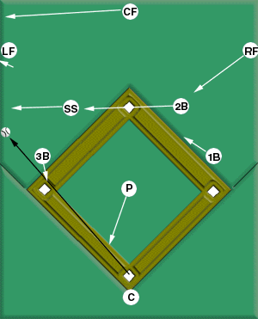**Catcher:** Cover home plate.
  + **Pitcher:** Stand between home plate and third base (closer to home), watch the play evolve, and back up the throw.
  + **First baseman:** Make sure the batter touches first base; then trail him to second.
  + **Second baseman:** Get to the trail position behind the shortstop. Let the shortstop know where to throw.
  + **Shortstop:** Line up between home plate and the fielder for the cut-off throw-20-30 feet behind based on age and field size
  + **Third baseman:** Cover third base.
  + **Left fielder:** Field the hit and make the cut-off throw to the shortstop.
  + **Center fielder:** Back up the left fielder.
  + **Right fielder:** Back up any throw to second base.

# Double, possible triple to the left center field gap: runners on base

**Catcher:** Cover home plate.

* **Pitcher:** Stand between home plate and third base (closer to home), watch the play evolve, and back up the throw.
* **First baseman:** Take the cut-off position for a throw to the plate.

**Second baseman:** Get to the trail position behind the shortstop - 20-30 feet behind based on age and field size

* **Shortstop:** Line up between home plate and the fielder for the cut-off throw.
* **Third baseman:** Cover third base.
* **Left fielder:** Back up the center fielder.
* **Center fielder:** Field the hit and make the cut-off throw to the shortstop.
* **Right fielder:** Back up any throw to second base.

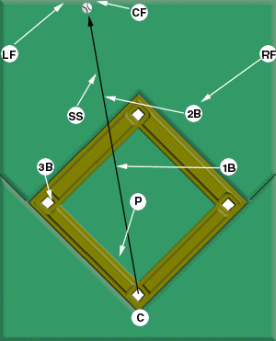

# Double, possible triple to the right center field gap: runners on base

* + 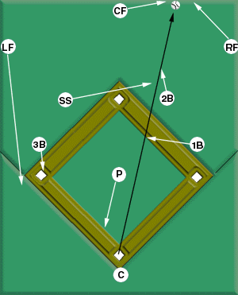**Catcher:** Cover home plate.
  + **Pitcher:** Stand between home plate and third base (closer to home), watch the play evolve, and back up the throw.
  + **First baseman:** Take the cut-off position for a throw to the plate.
  + **Second baseman:** Line up with home plate and the fielder for the cut-off throw.
  + **Shortstop:** Go to the trail position behind the second baseman.- 20-30 feet behind based on age and field size
  + **Third baseman:** Cover third base.
  + **Left fielder:** Back up any throw to third base.
  + **Center fielder:** Field the hit and make the cut-off throw to the second baseman.
  + **Right fielder:** Back up the center fielder.

# Double, possible triple down the right field line: runners on base

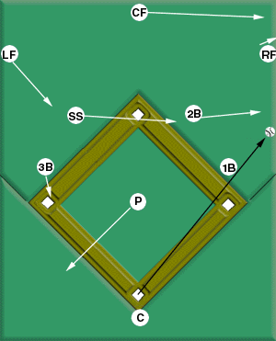

* **Catcher:** Cover home plate.
* **Pitcher:** Stand outside the base paths halfway between home plate and third base, watch the play evolve, and back up the throw.
* **First baseman:** Take the cut-off position for a throw to the plate.
* **Second baseman:** Line up with home plate and the fielder for the cut-off throw.
* **Shortstop:** Get behind the second baseman.Tell the second baseman where to make the throw. Be the cut- off man for a play at third base.
* **Third baseman:** Cover third base.
* **Left fielder:** Back up any throw to second base or third base.
* **Center fielder:** Back up the right fielder.
* **Right fielder:** Field the hit and make the cut-off throw to the second baseman.

# Sacrifice bunt: runner on first

* + 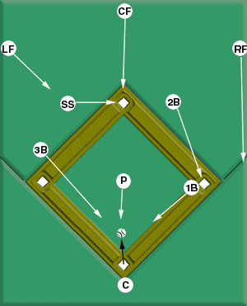**Catcher:** Tell the infielders where to throw.
  + **Pitcher:** Cover the middle of the field. If you field the ball, listen to the catcher's instructions, and then throw to the appropriate base.
  + **First baseman:** After holding the runner on first base, charge and cover the right side of the infield. If you field the ball, listen for catcher's instructions, and then throw to the appropriate base.
  + **Second baseman:** Cover first base.
  + **Shortstop:** Cover second base.
  + **Third baseman:** Charge toward home plate and cover the left side of the infield. (Be prepared to retreat quickly to third base to prevent the runner from advancing there.) If you field the ball, listen for catcher's instructions, and then throw to the appropriate base.
  + **Left fielder:** Come toward the infield in order to back up poor throws.
  + **Center fielder:** Back up any throw to second base.
  + **Right fielder:** Back up any throw to first base.

# Sacrifice bunt: runners on first and second, the infield goes for the out at first

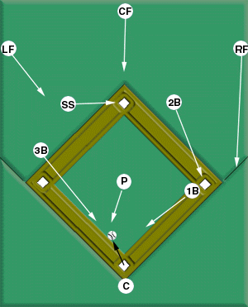

* + **Catcher:** Tell the infielders where the throw is going.
  + **Pitcher:** Cover the third base line. If you field the ball, listen to the catcher's instructions, and then throw to the appropriate base.
  + **First baseman:** Cover the right side of the infield. If you field the ball, listen for catcher's instructions, and then throw to the appropriate base.
  + **Second baseman:** Cover first base.
  + **Shortstop:** Cover second base.
  + **Third baseman:** Charge toward home plate and cover the left side of the infield. If you field the ball, listen for the catcher's instructions, and then throw to the appropriate base.
  + **Left fielder:** Back up any throw to second base.
  + **Center fielder:** Back up any throw to second base.
  + **Right fielder:** Back up any throw to first base.

# Wheel play: batter puts down a sacrifice bunt with runners on first and second,

**the defense goes for the force out at third**

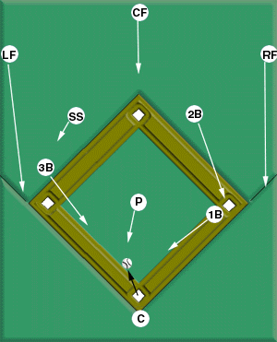

* **Catcher:** Tell the infielders where the throw is going. (Catchers must remember that no one is covering second on this play.
* **Pitcher:** The shortstop should break for third base before you deliver the pitch. Cover the middle of the field. If you field the ball, listen to the catcher's instructions, and then throw to the appropriate base
* **First baseman:** Cover the right side of the infield. If you field the ball, listen for catcher's instructions, and then throw to the appropriate base
* **Second baseman:** Cover first base
* **Shortstop:** Get behind the lead runner's right shoulder and break for third base as the pitcher sets
* **Third baseman:** Charge and cover the left side of the infield. If you field the ball, listen for the catcher's instructions, and then throw to the appropriate base
* **Left fielder:** Back up any throw to third base
* **Center fielder:** Come toward the infield to cover second base
* **Right fielder:** Back up any throw to first base

# Wheel play fake: runners on first and second with a pick-off play going to second

* 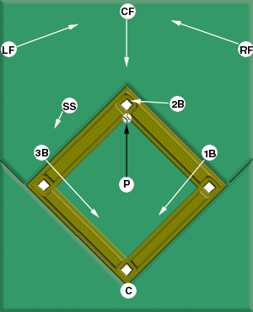**Catcher:** Cover home plate
* **Pitcher:** As the shortstop breaks for third base, make your pick-off throw to second base
* **First baseman:** Cover the right side of the infield as if the wheel play were on
* **Second baseman:** Fake a step toward first base, and then break for second base for the pick-off throw
* **Shortstop:** Position yourself behind the runner's right shoulder. Break for third base as if the wheel play were on
* **Third baseman:** Charge and cover the left side of the infield
* **Left fielder:** Back up the center fielder
* **Center fielder:** Back up the throw to second base
* **Right fielder:** Back up the center fielder